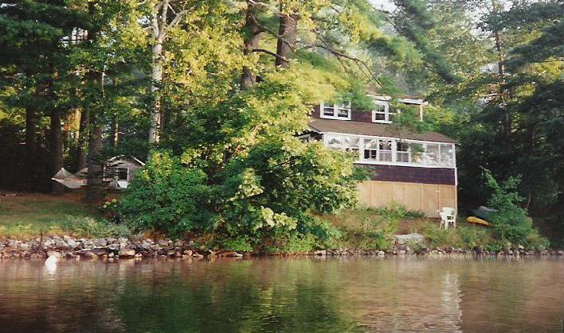


For Rent: Lake Cottage in Maine

A unique 1920’s cottage (“camp”) in Monmouth, Maine. On Sand Pond, a crystal clear lake complete with loons, one of five small lakes in the chain called Tacoma Lakes. Enjoy warm days, cool nights, perfect for swimming, walking, reading, writing… and relaxing.

Three bedrooms (sleeps 6 comfortably), living room, eat-in kitchen, bath, porches. Fully furnished and equipped, heat included if needed. Day trips to beaches, lighthouses, port villages. Overnights to Acadia National Park, Bar Harbor, and the White Mountains. Summer stock theatres, concerts, antiques, fairs and festivals nearby. About a one hour drive to Portland, three to Boston.

Contact:

Klara Tammany
15 Linden St.
Auburn, Maine 04210
207-786-7468
ktammany@megalink.net

www.themainecottage.com

Available May through October

Rent: $750/wk or $110/day Deposit: $110/wk
July & August rent by the week only (Saturday-Saturday).

PLEASE NOTE: Because we turn others away while holding a spot,
we do not refund deposits upon cancellations.

